

General Tso’s Tofu

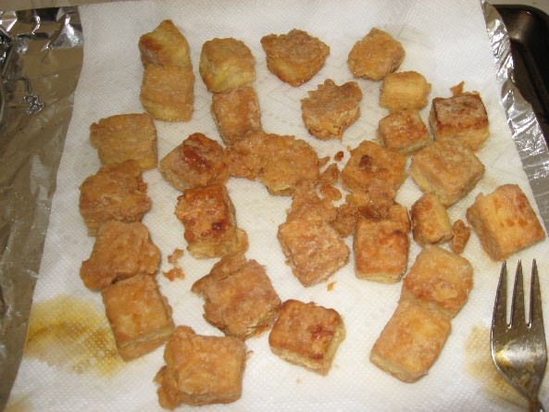

Ingredients:

* 1 lb    Tofu Extra Firm
* 4 T    Flour
* 1       Egg (beaten) or Egg Replacement
* 2 T    Vegetable or Corn Oil

Directions:

1. Pre-heat the skillet with the oil at Medium heat.
2. Cube the tofu into squares, approximate 1 inch each, using a serrated knife.
3. 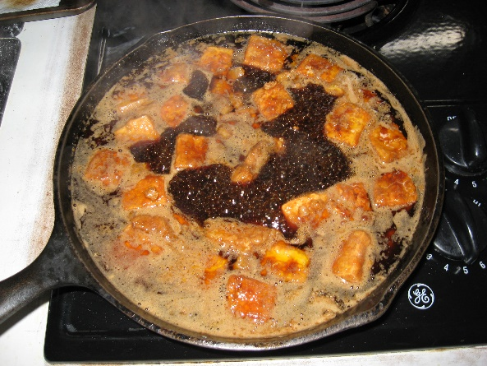In a separate bowl, coat the tofu cubes by dipping it into the Egg or Egg Replacement, then into the flour.
4. Place them into the skillet, turning them every few minutes.
5. Set aside, drain.

